Salary and Taxes - Corrected Full Answer

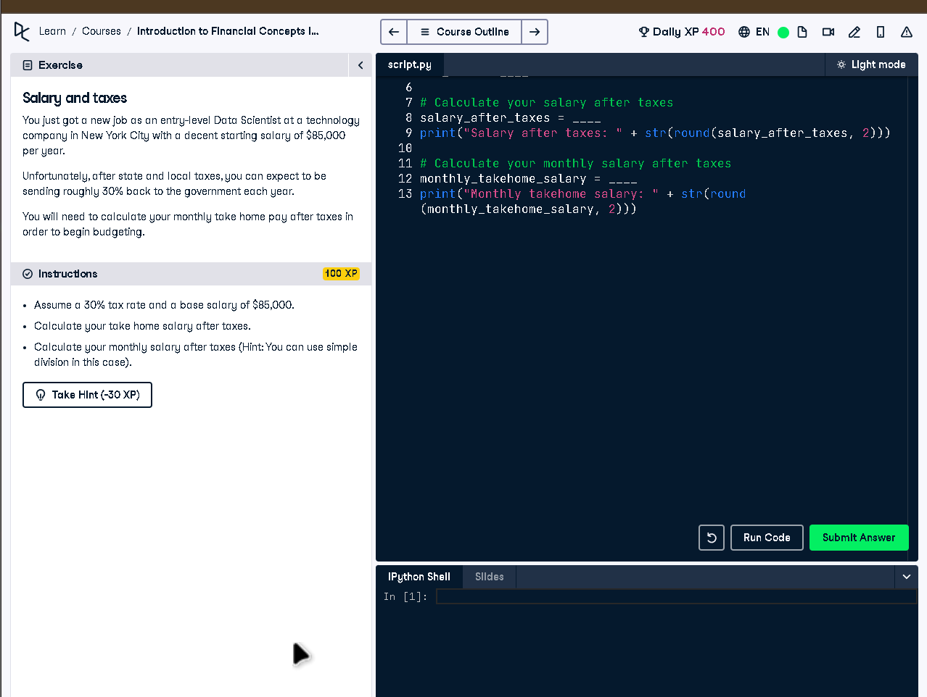

# Full Code Answer:

# Enter your annual salary  
salary = 85000  
  
# Assume a tax rate of 30%  
tax_rate = 0.30  
  
# Calculate your salary after taxes  
salary_after_taxes = salary*(1 - tax_rate)  
print("Salary after taxes: " + str(round(salary_after_taxes, 2)))  
  
# Calculate your monthly salary after taxes  
monthly_takehome_salary = salary_after_taxes / 12  
print("Monthly takehome salary: " + str(round(monthly_takehome_salary, 2)))

# Question:

How do you calculate annual and monthly take-home salary after a 30% tax rate on a base salary of $85,000?

# 20-word Explanation (Question):

Tax reduces total income by 30 percent annually. Divide resulting amount by 12 to find monthly take-home pay after taxes.

# Answer:

Use salary * (1 - tax_rate) for net salary, then divide by 12 for monthly after-tax income.

# 20-word Explanation (Answer):

Multiply salary by 70% for annual net, then divide by 12 to find how much you actually receive monthly.